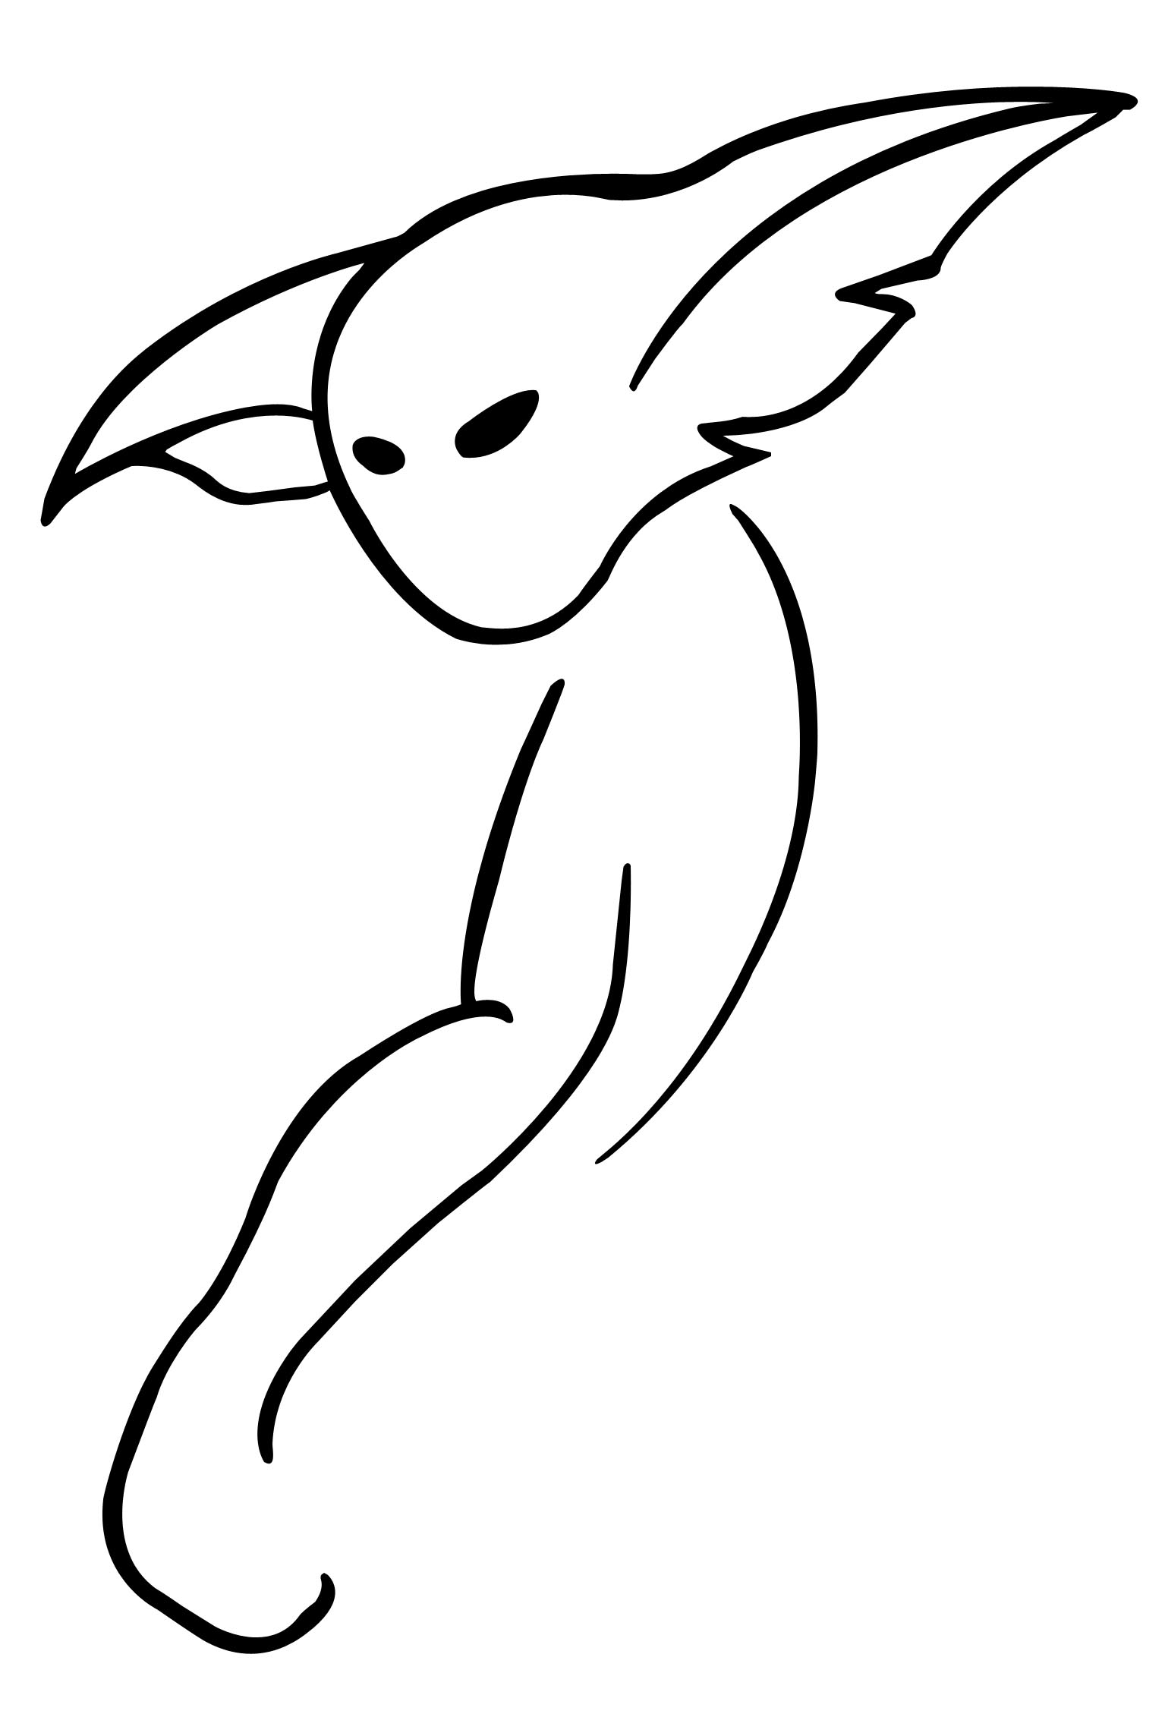



Les Armes
Parce que certaines personnes ne comprennent que la violence…

Arme | TD | Dégât | Difficulté | Spécial | Poids
Arbalète à cry | P | 5+carreau | 7 |  | 5.8
Arbalète à étrier | P | 5+carreau | 7 |  | 3.8
Arbalète à pied de biche | P | 5+carreau | 7 |  | 4.8
Arbalète à tour | P | 5+carreau | 7 |  | 5.8
Arbalète légère | P | 4+carreau | 7 |  | 1.9
Arc court | P | 3+flèche | 7 |  | 0.6
Arc long | P | 4+flèche | 8 |  | 0.8
Arpon | P | F+3 | 8 |  | 0.8
Bardiche | T | F+4 | 8 |  | 3.9
Bâton | C | F+2 | 7 |  | 1.4
Bille | C | 1+fronde | Fronde | Poids de : 0.1/10
Boomerang | C | F+1 | 9 |  | 0.4
Carreaux | P | Arbalète+1 | Arbalète | Poids de : 0.1/10
Crocs | P | F+2 | 6 |  | 0
Chaîne | C | F | 9 | 0.8/1m
Chakram | T | F+2 | 7 |  | 0.7
Cimeterre | T | F+4 | 7 |  | 1.9
Cognée | T | F+5 | 8 | + 1 C | 3.1
Corsèque | T | F+2 | 6 |  | 0.5
Couteau | T | F+1 | 6 | 0.1/2
Couteau de lancer | T | F+1 | 7 |  | 0.1
Coutelas | T | F+3 | 7 |  | 1.2
Dague | T | F+2 | 6 |  | 0.4
Epée à deux mains | T | F+7 | 9 |  | 3.5
Epée bâtarde | T | F+6 | 8 |  | 2.2
Epée courte | T | F+3 | 7 |  | 1.2
Epée à une main | T | F+4 | 7 |  | 1.5
Epieux | P | F+3 | 7 |  | 1.3
Espadon | T | F+7 | 9 | +1 C | 5
Etoile ninja | T | F+1 | 8 | 0.1/5
Fauchard | T | F+5 | 8 |  | 4.1
Fauchon | T | F+3 | 7 |  | 1.1
Faux | T | F+4 | 95 |  | 2.8
Fléau | C | F+3 | 8 |  | 2
Fléau d’arme | C | F+5 | 9 |  | 3
Fléau d’arme à pointes | C | F+5 | 9 | +2 P | 3.3
Fléau de guerre | C | F+6 | 95 |  | 4.9
Fléau de guerre à pointes | C | F+6 | 95 | +2 P | 5.2
Flèche | P | Arc+2 | Arc | 0.1/5
Fleuret | P | F+2 | 7 |  | 0.3
Fouet | T | F+2 | 8 |  | 0.5
Fourche | P | F+3 | 8 |  | 2
Fronde | C | F+bille | 8 |  | 0
Glaive | T | F+2 | 6 |  | 0.9
Godendac | C/P | F+5 | 8 |  | 4.5
Goupillon | C | F+3+1/tête | 95 | +1 P/tête 1.4+1/t.
Gourdin | C | F+2 | 6 |  | 1.1
Grappin | P | F+1 | 7 |  | 0.1
Griffe | T | F+1 | 5 |  | 0
Hache d’armes | T | F+5 | 8 |  | 2
Hache de bataille | T | F+6 | 9 | +1 C | 3.5
Hache de jet | T | F+4 | 8 |  | 0.7
Hachette | T | F+3 | 7 |  | 1.2
Hachoir | T | F+3 | 8 |  | 1
Hallebarde | T/P | F+5 | 8 |  | 4.2
Javelot | P | F+3 | 7 |  | 1
Katana | T | F+3 | 7 |  | 1.5
Khukri | T | F+2 | 7 |  | 0.5
Kriss | T | F+2 | 6 |  | 0.4
Lance | P | F+4 | 8 |  | 1.6
Lance de cavalerie | P | F+5 | 9 |  | 7
Lance-pierres | C | 2+bille | 7 |  | 0.1/2
Langue-de-bœuf | T | F+5 | 8 |  | 2.5
Machette | T | F+3 | 8 |  | 1
Main gauche | T | F+2 | 7 |  | 0.8
Marteau | C | F+2 | 7 |  | 2
Marteau de guerre | C/P | F+5 | 7 |  | 4
Marteau de guerre lourd | C/P | F+7 | 9 |  | 5.8
Masse | C | F+4 | 8 |  | 3.8
Masse d’armes | C | F+4 | 7 |  | 3.5
Masse de guerre | C | F+5 | 8 |  | 4
Massue | C | F+3 | 7 |  | 1.5
Massue à pointes | C | F+3 | 7 | + 1 P | 1.7
Matraque | C | F+1 | 6 |  | 0.8
Miséricorde | T | F+2 | 6 |  | 0.1
Morgenstern | C | F+4 | 7 | + 2 P | 4
Naginata | T | F+4 | 8 |  | 3.8
Nunchaku | C | F+2 | 9 |  | 0.4
Ninjato | T | F+2 | 6 |  | 0.4
Pelle | T/C | F+2 | 8 |  | 2
Pertuisane | T | F+5 | 8 |  | 4.1
Pieux | P | F+2 | 6 |  | 0.3
Pioche | P | F+4 | 9 |  | 2.2
Pique | P | F+4 | 9 |  | 2.2
Poignard | T | F+2 | 6 |  | 0.2
Rapière | T | F+3 | 7 |  | 0.9
Rasoir | T | F+2 | 7 | 0.1/2
Râteau | P | F+1 | 8 |  | 2
Sabre | T | F+4 | 7 |  | 1.8
Sagaie | P | F+3 | 7 |  | 0.8
Saï | P | F+2 | 6 |  | 0.5
Sarbacane | P | F | 7 |  | 0.1
Scalpel | T | F | 6 |  | 0.1/2
Serpe | T | F+1 | 8 |  | 0.4
Serpette | T | F+1 | 7 |  | 0.2
Shuriken | P | F+1 | 8 | 0.1/5
Stylet | T | F+1 | 6 | 0.1/2
Tanto | T | F+1 | 6 |  | 0.3
Tomahawk | T | F+3 | 7 |  | 0.6
Tonfa | C | F+2 | 9 |  | 0.5
Torche | C | F+1 | 7 | + 1 E | 1.7
Trident | P | F+5 | 9 |  | 3
Trique | C | F+2 | 7 |  | 1.3
Vouge | T | F+5 | 8 |  | 4.3
Wakizashi | T | F+3 | 7 |  | 0.8
Yatagan | T | F+4 | 7 |  | 1.8
Zabatoff | T | F+4 | 8 |  | 4.2

